**Assignment -1** Python Programming

|  |  |
| --- | --- |
| Assignment Date  Student Name  Student Roll Number  Maximum Marks | 26 September 2022  Ms.Dhanya.R  621319106015  2 Marks |

**Question-1:**

Build a python code, Assume you get temperature and humidity values ( generated with random function to a variable) and write a condition to continuously detect alarm in case of high temperature.

Program:

t=int(input("enter the temperature"))

h=int(input("enter the humidity"))

while(t>35):

print("buzzer on")

Program 2: import time

from random import randint file=open("data.txt","a") n=5

for i in range(n): humidity=randint(0,100)+1 temperature=randint(-100,100)+1 if humidity>45:

print("\n \n Humidity High") print(humidity)

file.write("\nHumidity") file.write(str(humidity))

if temperature>30: print("Temperature High") print( temperature)

file.write("\nTemperature") file.write(str(temperature))

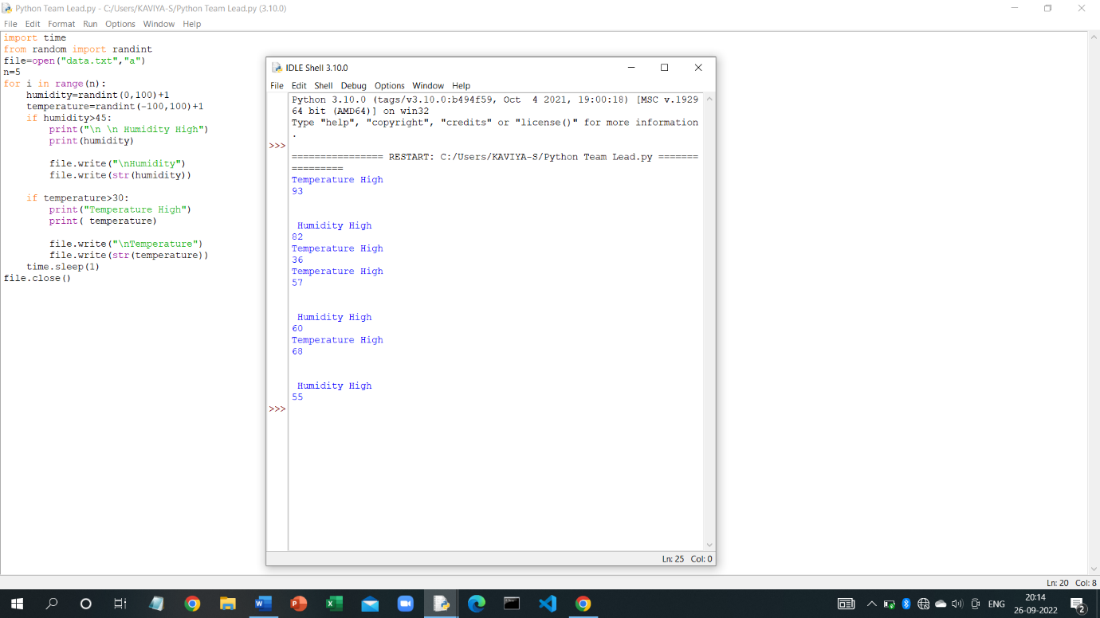time.sleep(1) file.close()